Name-Satish Kumar
Roll NO- 244CA046
MCA
Semester -II

MA611 - Database Management Systems Lab

create table classroom (
building varchar(15),
room_number varchar(7),
capacity numeric(4,0),
primary key (building ,room_number)
;

OUTPUT
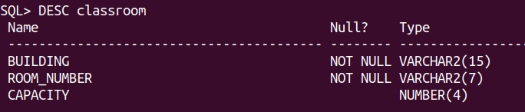

create table department(
debt_name varchar(20),
building varchar(15),
budget numeric(12,2) check(budget >0) ,
primary key (debt_name)
);
OUTPUT-
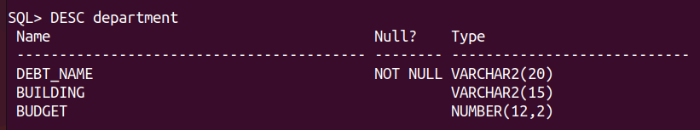

CREATE TABLE course (
course_id VARCHAR(8),
title VARCHAR(50),
dept_name VARCHAR(20),
credits NUMERIC(2,0) CHECK (credits > 0),
PRIMARY KEY (course_id),
FOREIGN KEY (dept_name) REFERENCES department ON DELETE SET NULL
);

OUTPUT-

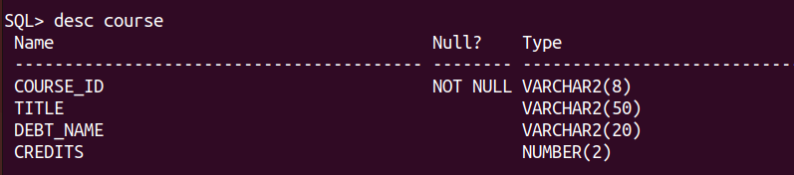

create table instructor(
ID varchar (5),
name varchar(20) not null ,
debt_name varchar(20),
salary numeric(8,2) CHECK (salary >29000),
primary key(ID) ,
foreign key(debt_name) references department
on delete set null
);

OUTPUT-
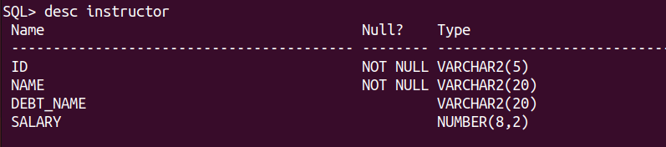

create table section (
course_id varchar(8),
sec_id varchar(8),
semester varchar(6),
check (semester in ('Fall', 'Winter','Spring' ,'Summer')),
year numeric(4,0) check (year>1701 and year <2100),
building varchar(15),
room_number varchar(7),
time_slot_id varchar(4),
primary key(course_id ,sec_id,semester,year),
foreign key (course_id) references course
on delete cascade ,
foreign key (building ,room_number) references classroom
14 on delete set null);

OUTPUT-
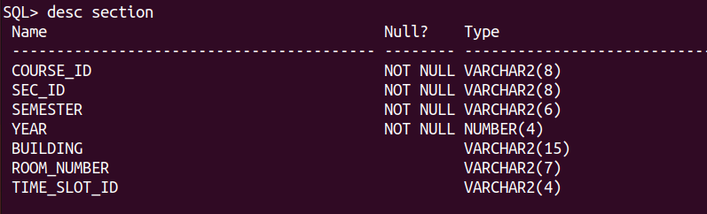

create table teaches (
ID varchar(5),
course_id varchar(8),
sec_id varchar(8),
semester varchar(6),
year numeric(4,0),
primary key(ID ,course_id ,sec_id,semester,year),
foreign key (course_id,sec_id,semester,year) references section
on delete cascade ,
foreign key (ID) references instructor
on delete cascade );
OUTPUT-

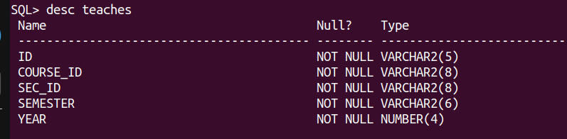

create table student (
ID varchar(5),
name varchar(20) not null ,
debt_name varchar(20),
tot_cred numeric(3,0) check (tot_cred >=0),
primary key(ID),
foreign key (debt_name) references department
on delete set null
);

OUTPUT -
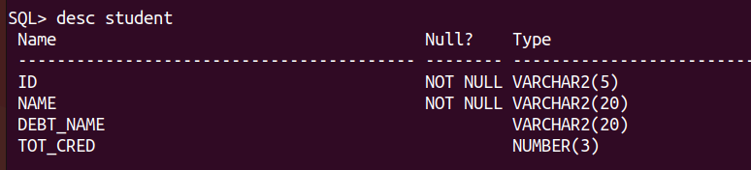

create table takes(
ID varchar(5),
course_id varchar(8),
sec_id varchar(8),
semester varchar(6),
year numeric(4,0),
grade varchar (2),
primary key (ID ,course_id ,sec_id,semester,year),
foreign key (course_id,sec_id,semester,year) references section
on delete cascade ,
foreign key (ID) references student
on delete cascade );

OUTPUT-

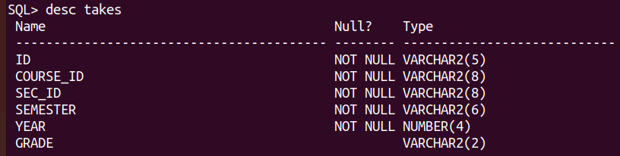
create table advisor
( s_Id varchar(5) ,
i_ID varchar (5) ,
primary key (s_ID),
foreign key (i_ID) references instructor(ID)
on delete set null ,
foreign key (s_ID) references student (ID)
on delete cascade );
OUTPUT-
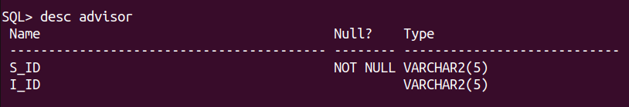
create table time_slot(
time_slot_id varchar(4),
day varchar(1),
start_hr numeric(2) check (start_hr >=0 and start_hr <24),
start_min numeric(2) check (start_min >=0 and start_min < 60),
end_hr numeric(2) check (end_hr >=0 and end_hr <24),
end_min numeric(2) check (end_min >=0 and end_min < 60),
primary key (time_slot_id, day ,start_hr,start_min)
);
OUTPUT -
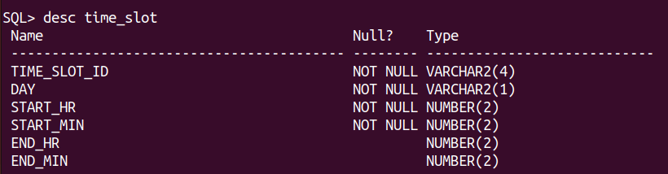

create table prereq (
course_id varchar(8),
prereq_id varchar(8),
primary key(course_id ,prereq_id),
foreign key (course_id) references course
on delete cascade,
foreign key (prereq_id) references course
);
OUTPUT-
